Retention at WSU: Research and Review 1/8/16
Executive Summary & Best Practices
Washington State University has a number of positive retention efforts in place, yet retention continues to be a concern. Over the past couple of years a number of efforts have been made to gather data to better understand the issues around retention and persistence. This report attempts to gather all of that information into one place, and look for trends across the data.
Overall, these data suggest some areas where we might place additional efforts:
- Support for student mental health
- Represent a more supportive environment outside of class (student and administrative services)
- Assist incoming students in understanding the academic demands and ensure adequate support and information regarding appropriate study skills, time management, etc.
*Note: Much of the research cited here is specific to the Pullman campus. The literature suggests different strategies would be effective, on our different campuses as issues at residential, non-residential and online campuses differ. Therefore, where possible it makes sense to look at the campuses separately.
The bulleted items below summarize the most noteworthy findings from data sets currently available.
- IR research: Pullman - Primary focus has been on tracking first time entering freshmen. Predictive factors for retention at WSU are consistent with external research:
- Entering HS GPA – GPAs below 3.0 pose a fairly high risk of non-retention
- First Generation (less likely to persist)
- F & R Lunch status in High School (SES) (high free and reduced lunch (> 50% at the school) are less likely to persist
- Residency status (in-state students are more likely to persist)
- Financial need <$7,000 (more likely to persist)
- NSSE 2014 (n=1251) (All WSU)
  - WSU averages are below Institutional peers for Supportive Environment and Quality of Interactions. Taken together these findings suggesting we could do better in supporting and interacting with our students.
  - NSSE findings also suggest that, across the WSU system, we need students more engaged in High Impact Practices (HIP). While over half of first year students participate in at least one HIP, only 10% participate in more than one, less than institutional peers.
- NSSE 2014 PULLMAN
  - Specific to Pullman, students are well engaged HIP in comparison to legislative peers.
  - First year and Senior students are below legislative peers for Supportive Environment and Quality of Interactions and Supportive Environment.
  - Looking at the highest and lowest performing relative to legislative peers:
    - Strengths:
      - Engagement with faculty: Discussing career plans with a faculty member, and discussing course topics, ideas or concepts with a faculty member outside of class are amongst WSU’s highest performing factors.
      - Both first year and seniors indicate and many courses include a community based project and seniors indicate they’ve participated in a culminating experience.
    - Concerns:
      - Lack of support: Lack of institutional emphasis on helping students manage non-academic responsibilities and quality of interactions with student services and other administrative staff and offices are amongst WSU’s lowest performing items.
      - In addition, for seniors, participated in an internship, co-op or field experience is one of the lowest performing items.
- National College Health Assessment 2012 (n=3908) & 2014 (n=4078) (Pullman)
  - Respondents identify a number of items perceived to negatively impact their academic performance. Related to mental health, respondents identified stress (30%), anxiety (21%), depression (12%) and/or relationship difficulties (10%) as negatively impacting their academic performance. These numbers are almost identical to the NCHA 2015 Reference Group
Further, significant number of respondents indicated not receiving information from WSU on depression/anxiety (55%), relationship difficulties (67%), stress reduction (43%) or suicide prevention (67.2%). In addition 20% of respondents indicated they had considered suicide within the last year suggesting more support in terms of mental health issues is warranted.
  - Other items identified as negatively impacting academic performance, by greater than 10% of respondents included, lack of sleep (25%), Internet/video games (15%) and work (11%). Of respondents to this survey, less than half are employed and 30% employed less than half-time. Again, these numbers are very similar to the NCHA 2015 Reference Group
- ENGAGE Fall 2012
  - If used as intended, this survey would help identify students at risk for dropping out and allow for increased intervention by advisors or other support staff.
  - Reviewing the aggregate data for the single administration of this instrument, WSU students’ percentile scores were below the national sample on all 10 constructs (all differences being statistically significant) with the largest differences found in Academic Discipline, Academic Self-confidence and Commitment to College.
    - Academic Discipline – the amount of effort a student puts into schoolwork and the degree to which a student sees him/herself as hardworking and conscientious.
    - Commitment to College: Commitment to staying in college and getting a degree.
    - Academic Self-confidence: The belief in one’s ability to perform well in college.
  - This data suggests that the incoming class of Fall 2012 was not prepared for the academic rigors of WSU.
- LASSI – Delivered Fall 2014, the third week of the term, to 485 first year students across a range of courses. The LASSI is a 10-scale, 80-item assessment of students' awareness about and use of learning and study strategies related to skill, will and self-regulation components of strategic learning. Like ENGAG, the LASSI provides students feedback in whereas where they may be weak and need to improve knowledge, attitudes, beliefs and skills. Students who completed the LASSI did slightly better in their fall semester than students who did not complete the assessment.

There is not a national sample for comparison to WSU student scores. WSU students scored lowest in “Attitude” and “self-testing”
  - The Attitude Scale assesses student’s attitudes and interest in college and academic success.
  - The Self-Testing Scale assesses students' use of reviewing and comprehension monitoring techniques to determine their level of understanding of the information to be learned
- Educational Benchmarking Survey (Res Life) ?
- First Year Focus:
  - Data from the Educational Benchmarking, Inc. survey, administered Fall 2012, 2013 & 2014 comparing Freshman in FYF to other freshmen, consistently the data indicate that the experience positively impacts factors known to predict persistence of students.
    - Increase students’ interaction with faculty and staff
    - Increase students’ personal interaction with other people
    - Affect retention and graduation through increased student engagement.
- Propensity analysis of HD 205 suggests that students who complete this course are more likely to be retained by the university. Taken with the pre/post data from the course, three factors seem to be key to the retention of these students: connection, values and mindfulness (Kidwell, 2014). It is also noteworthy that the data from this courses shows a significant increase in positive mental health from pre to post test, five of six semesters, indicating we can perhaps positively impact potential mental health issues through our academic courses.
- ROOTS (History 105 & 305) (PI- Jesse Sponholz and Clif Stratton): Data is being collected, on all campuses, for students who reach first year competency level on the research paper assignment, vs those who do not. In other words, this data provides some insight into the relationship between academic ability and success. Data for AY 2014-2015 suggests the following:
  - Students fail because they don’t turn in the work, not because they can’t do the work or their skills are below the level of those who pass the class, suggesting that retention is not related to academic ability.
  - Students are more successful in classes with Teaching Assistants, suggesting more academic support is beneficial.
  - Q-value and first gen status are predictive of success.
- Vancouver BSSE findings suggest that incoming students may have unrealistically low expectations regarding the level of academic difficulty they will encounter during their first year of college. It would be helpful to know if this finding is consistent across the WSU system, and look for ways for recruiters and recruiting materials to address.

In sum, as a system WSU may benefit from becoming more supportive for students. We need to find more and better ways to engage students with faculty and with the university. We need to ensure expectations of incoming students are realistic and that students can access support when life becomes challenging. We also need to help faculty understand their role in student retention and facilitate more opportunity for student faculty interaction.

In addition, we need to develop a better understanding of WSU student culture, priorities, and expectations in order to best understand how to positively impact class attendance, academic integrity, and retention and graduation rates.

Lastly, while there are a number of retention initiatives in place, there seems to be little existing data as to the effectiveness of these efforts on specific groups of students identified as least likely to persist.

It is suggested that we adopt an assessment instrument to administer to entering freshmen each year and track through to graduation to continue to develop our understanding of retention issues and potential solutions for Washington State University.

Literature Review & Best Practices
Nationally, despite a prevalence of high-impact practices in place, graduate rates are flat.
Tinto (1993) describes three principles of effective retention gleaned from successful retention programs at different colleges and universities. Institutional commitments underscore these three principles:
- commitment to student welfare,
- commitment to the education of all students
- Commitment to the integration of all students into the academic and social communities at an institution.
Factors influencing retention
- Academics
  - Academic preparedness
  - GPA and credit completion trends
  - Timeliness of major identification
  - Educational Aspirations
  - Hours studied per week
  - Success in foundational courses
- sense of belonging
  - Student Involvement
  - Fit of the university
  - Expectations (brand)
  - First choice institution
  - Perceptions of faculty/connection with faculty
  - Commitment to the school
- Demographics
  - SES
  - First gen
  - Race
  - Gender
  - residency
- Health
- Financial support
Strategies
Best Practices:
- Communicate to parents, students, faculty and staff how to access resources and support systems on campus and continuously promote awareness of such programs and policies so that a supportive living and learning environment is fostered.
  - Faculty, staff, academic advisors should attend to the holistic development of the student
- Incorporate into courses
  - Social – Psychological Interventions (persuasive communication) (Yeager & Walton, 2011)
    - Sense of belonging
    - Growth Mindset
    - Value affirmations
    - Personal relevance
    - Levels of learning
    - Meditation
  - Civic engagement/community base service learning projects
  - Internships
- Engage students in the campus environment (students living and working on campus are more likely to finish in 4 years or less (Letkiewica et. al, 2015).
  - Engage students in extra and co-curricular activities
    - Study Abroad
    - Research projects
- Early assessment/intervention of “fit” Student responses just 8 weeks into the first semester were predictive of subsequent enrollment patterns (Campbell & Mislevy, 2013). Simply asking students “how do you like it here” can help identify those at risk for dropping out.
- Providing on campus financial counseling centers and financial programs. (Letkiewica et. al, 2015)
- Formation of learning communities and cohort based programs
- Freshman Seminars
- First year mentor matching
- Early alert/warning
  - SSC Campus/My WSU/OBIEE
    - Utilize data to identify at risk students
    - Targeted campaigns
      - Murky middle - “Murky Middle” students leave later, but trends foreshadow departure several terms in advance. (EAB)
      - High end – graduate school
      - Low end – support and resources
      - Success marker courses
      - Students with holds/not yet enrolled for the next term
    - Success Markers
Advising policies and practices (EAB)
- Mandatory exit interview for leavers
- Automated withdrawal advising
  - Automated advising survey prompted; walks students through consequences and campus resources

Faculty Role in Student Success
- Big Six College Experiences Linked to Life Preparedness (Gallup)
- A professor who made them excited to learn;
- A professor who cared about them as individuals;
- A mentor who pushed students to reach their goals;
- Working on a long-term project;
- Completing a job or internship related to classroom lessons;
- Students being engaged in extracurricular activities and groups
- Faculty mentoring and out of class research projects with student(s)
- Incorporate service learning into courses
- Identify/monitor at risk students – reach out or refer to advising staff
  - Class attendance
  - Early academic performance
  - Concerning behavior (e.g. sleeping in class, under the influence, non-participatory, etc.)
- Teaching Innovation (EAB – separate attachment)
  - Active learning: Increases student engagement and satisfaction
  - gateway courses: Adaptive Learning – self-paced learning – increases support,
  - Bottleneck courses: Flipped/Hybrid – Increases capacity
  - Innovation and change brings risk Barriers include
    - risk to annual review (negative course evaluations, increase DFW)
      - re-envision evaluation of teaching
      - Revise tenure guidelines
    - Time to re-envision detracts from time to research
    - Need an exit strategy – what if innovation fails
    - What if the technology does not work
  - Promotion of collaborative/cooperative learning
Remove curricular barriers to completion and decrease time to graduation (EAB):
- Allow students to enroll in courses for multiple semesters
- Accelerated Degree Pathways
- Competency-based education
- Semester alternatives
  - Alabama’s 10 wk redirect course for students identified “at risk” the first 5 weeks of the term.
  - Developmental courses of varying length
  - Strategically utilize existing WSU 3-wek (intersession, winter session and maymester) to deliver gateway & high demand courses.
  - WSU Speech & Hearing Sciences offers sign language 201 & 202 each 4 weeks back to back in one term allowing students to
- Prior Learning Assessment

An example of an innovative initiative happening at WSU Tri-Cities:
Project Overview WSU Tri-Cities, Pasco School District and LIGO will collaborate on a continuation of the Collaboratory’s original STEM Flicks project. WSU TC Digital Technology and Culture (DTC) students will produce two 5-7 minute videos for the project, one each during the spring semesters of the 2016 and 2017 academic years. WSU TC students in physics and education will support the making of the films by respectively contributing science content expertise and the development of web-based teacher support materials to accompany the videos. High school students from the Pasco School District, working with the guidance of a PSD teacher who will serve as part of the project team, will play lead roles in the storylines of the videos. LIGO Hanford Observatory will serve as the filming location for both videos. The PSD students will narrate the videos on-site at LIGO, interacting with LIGO scientists, engineers, and student employees (both of whom are currently WSU TC students) to tell stories that illustrate Next Generation Science Standards Science and Engineering Practices in the context of cutting edge astrophysics research. PSD high school science classrooms will serve as test sites for the videos, with teachers and students providing beta-test feedback. Upon completion and evaluation, the videos will join the Collaboratory STEM Flicks web collection and will be advertised to all Collaboratory constituencies. STEM Flicks II will align with the objectives and methods of the original STEM Flicks project, leveraging PNNL’s STEM Flicks expertise as fully as possible through face-to-face consultations and through the extensive documentation that the STEM Flicks team has created.

https://ligo.caltech.edu/WA
https://www.midcolumbiastem.org/Pages/Flicks.aspx

Retention Initiative at WSU (as compiled by Jerman Rose – this is a working document)
Name | Activity | Why do we think  this will work? | How do we  measure success? | Measures | Who is in  Charge?
 |  |  | Students Graduate
PASS | Freshman seminar
TOPS | multiple
Passport to College | multiple
Global leadership | courses
Undergrad Research
SURCA | poster sessions
Writing Program | tutors
PAWS | multiple
Calculated Success | bootcamp | good math is essential  for success
Week of Welcome | multiple
Save a Seat | early certification | students secure that  they will get what they want
Automatic enrollment
freshman courses
Cougar Success site
Course redesign grants | course redesign | improve DFW rates |  | DFW rates
Teaching Innovation Series | workshops | if teachers are up to date they'll be more effective
Test Kitchen | Access to teaching  technology
Success Collaborative | Advising | early warning allows  remediation
Teaching Academy
Student tech tools(multiple) | multiple | students control their program
LASSI
Online advising tools
Biology courses
HD 250 | Skill and confidence building | students drop out from lack of  skills and confidence
RA Education Directors | intervene mid term | if students get help they'll persist
ASCC Tutoring | scheduled tutoring | if students get help they'll persist
Health and Wellness workshops | multiple | if students get help they'll persist
UREC programs | multiple | active students get better grades

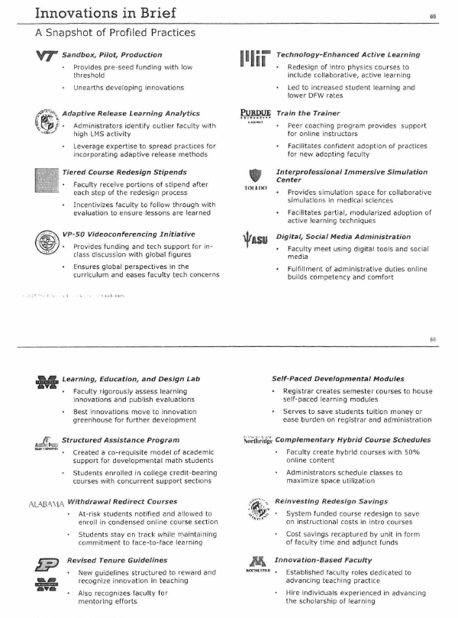
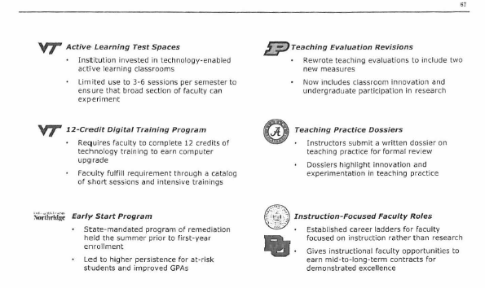

References:
Braxton, J. & Mundy, M. (2001-2002). Powerful institutional levers to reduce college student departure. J. College Student Retention, 3(1) 91-118.
Nora, A. (2001-2002). The depiction of significant others in Tinto’s “Rites of Passage”: A reconceptualization of the influence of family and community in the persistence process. J. College Student Retention, 3(1) 91-118.
Campbell, C. & Mislevy, J. (20012-2013). Student perceptions matter: Early signs of undergraduate student retention/attrition. J. College Student Retention, 14I(4), 467-493
Hoffman, M., Richmond, J., Morrow, J., & Salomone, K. (2002-2003). Investigating “sense of belonging” in first-year college students. J. College Student Retention, 4(3), 227-256
Findings from this investigation indicate that “sense of belonging” to the institution stems from perceptions of “valued involvement” in the collegiate environment. This perception of “valued involvement” appears predicated on: 1)establishing functionally supportive peer relationships –“functional” in terms of the ability of the relationship(s) to directly aid students in meeting the challenges and changes of their new environment: and 2) the belief that faculty are compassionate and that the student is more than just another face in the crowd.
Scaling Learning Innovations: From Early Adopters to Campus-Wide. Education Advisory Board, 2015 (Attachment 1: Innovations in Brief)
Meditation References:
http://link.springer.com/article/10.1007/s12671-013-0199-5#/page-2
http://www.sciencedaily.com/releases/2013/04/130409131811.htm
Johnson, S.K., Goolkasian, P. & David, Z. (2010),Mindfulness meditation improves cognition: evidence of brief mental training. Consciousness and Cognition: An Internal Journal, 19, 597-605
Moore, A. & Malinowski, P. (2009). Meditation, mindfulness and cognitive flexibility. Consciousness and Cognition, 18, 176-186.
Shapiro, S.L., Brown, K.W., & Astin, J. (2011). Toward the integration of meditation into higher education: A review of research evidence. Teachers College Record, 113, 493-528.
Big Six College Experiences Linked to Life Preparedness: http://www.gallup.com/poll/182306/big-six-college-experiences-linked-life-preparedness.aspx

